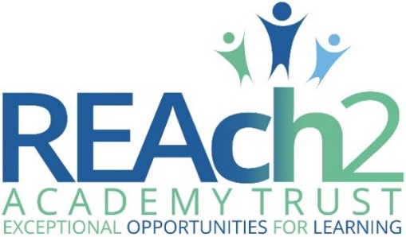

**Are you an exceptional teacher seeking your next exciting career move?**

Green Park Village Primary Academy is a new school opening in a stunning new building in September 2020. It will become the fourth REAch2 school in Reading, each serving a diverse community.   
  
We are seeking a cohort of exceptional teachers interested in joining our Reading Team in preparation for the opening of our new school. You will be warmly welcomed into the REAch2 Academy Trust and will work with the existing teams in the Reading Cluster 9 group from January onwards.   
  
This is an exciting opportunity to add additional capacity to our cluster of schools, including the potential to design and develop the core offer of high quality teaching and learning provisions for Green Park Village Primary Academy pupils as well as working with the Senior Leadership Teams on developing bespoke curriculums across the Reading schools.   
  
If you have interest or specialism in a core or foundation subject, this could be a wonderful opportunity to be part of teaching, creating, trialling and leading on our curriculum work over the forthcoming months.

If you wish to have an informal discussion, to see the plans for Green Park Village Primary academy or to visit the other Reading schools to see what it’s like to be part of the REAch2 family, please contact **Gemma Jackson, Head Teacher- designate (Green Park Village Academy)**:

Tel: 01184676222 or 01184676720

Email: [office@greenparkvillageacademy.org](mailto:office@greenparkvillageacademy.org)

We look forward to receiving interest and applications from individuals who thrive on working collaboratively and who enjoy making a difference to the experiences of children in diverse settings.

**Please note:** Applications must be submitted on a REAch2 application form and the deadline for submission is **noon on Friday 18th October 2019**. Selection process will be week commencing 21st October 2019.

***The successful candidate will be subjected to REAch2’s vetting checks including an enhanced DBS and disqualification check in line with our safeguarding principles.***